Reason #1 to Affiliate this school year: All FCCLA members have the opportunity to choose from more than 50 Competitive Events. Affiliation opens August 1! Don't miss this opportunity to compete Beyond Measure!
Comment below with your favorite Competitive Event!

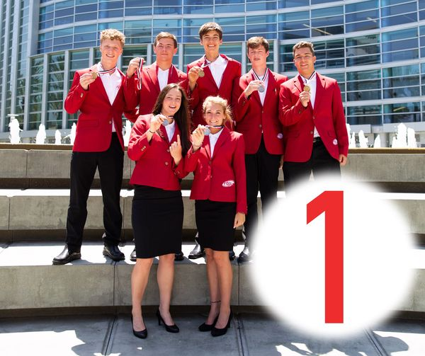

Reason #2 to Affiliate: You have the opportunity to network with members from around the country! With social media, zoom calls, and webinars, spread the word and talk about your favorite part of FCCLA!
What’s your favorite way to network?

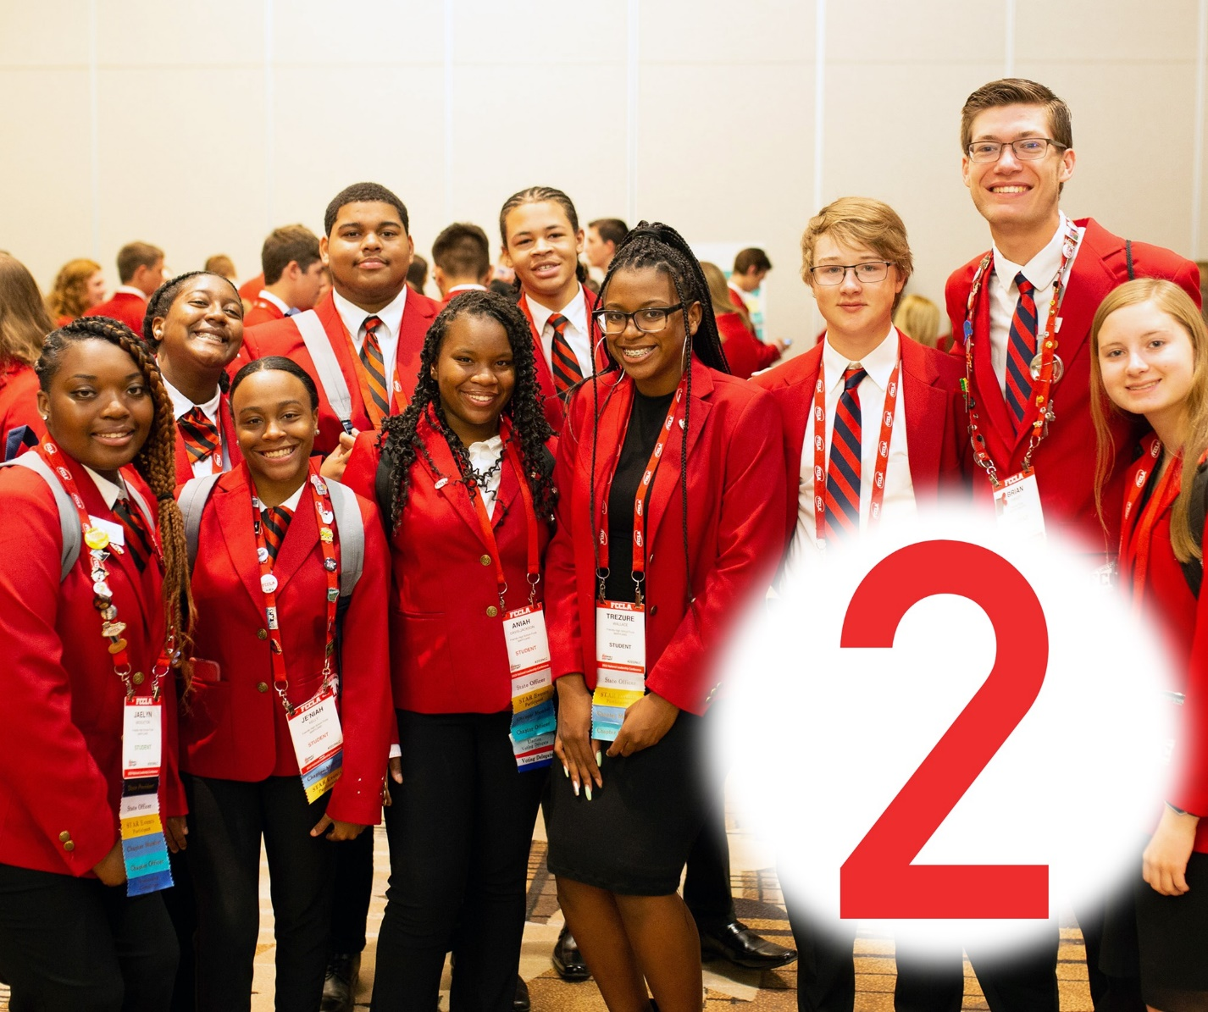

Reason #3 to Affiliate: The many scholarship opportunities that can help go towards your college career!
Name your dream college!
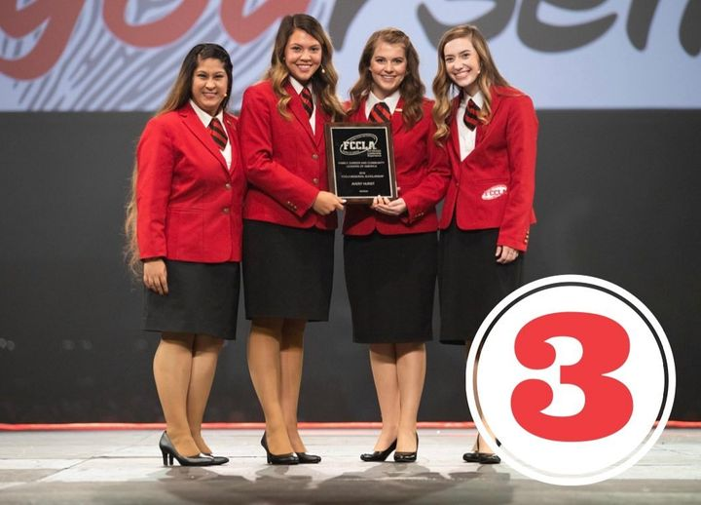

Reason #4 to Affiliate: Learn real world skills and explore FCCLA’s four Career Pathways!
What Career Pathway are you interested in pursuing a career in?

Reason #5 to Affiliate: The opportunity to attend FCCLA’s national conferences!
Whether traveling to a new city or participating virtually, FCCLA’s conferences bring members together from across the nation to learn, compete, and network!
What is your favorite FCCLA conference?

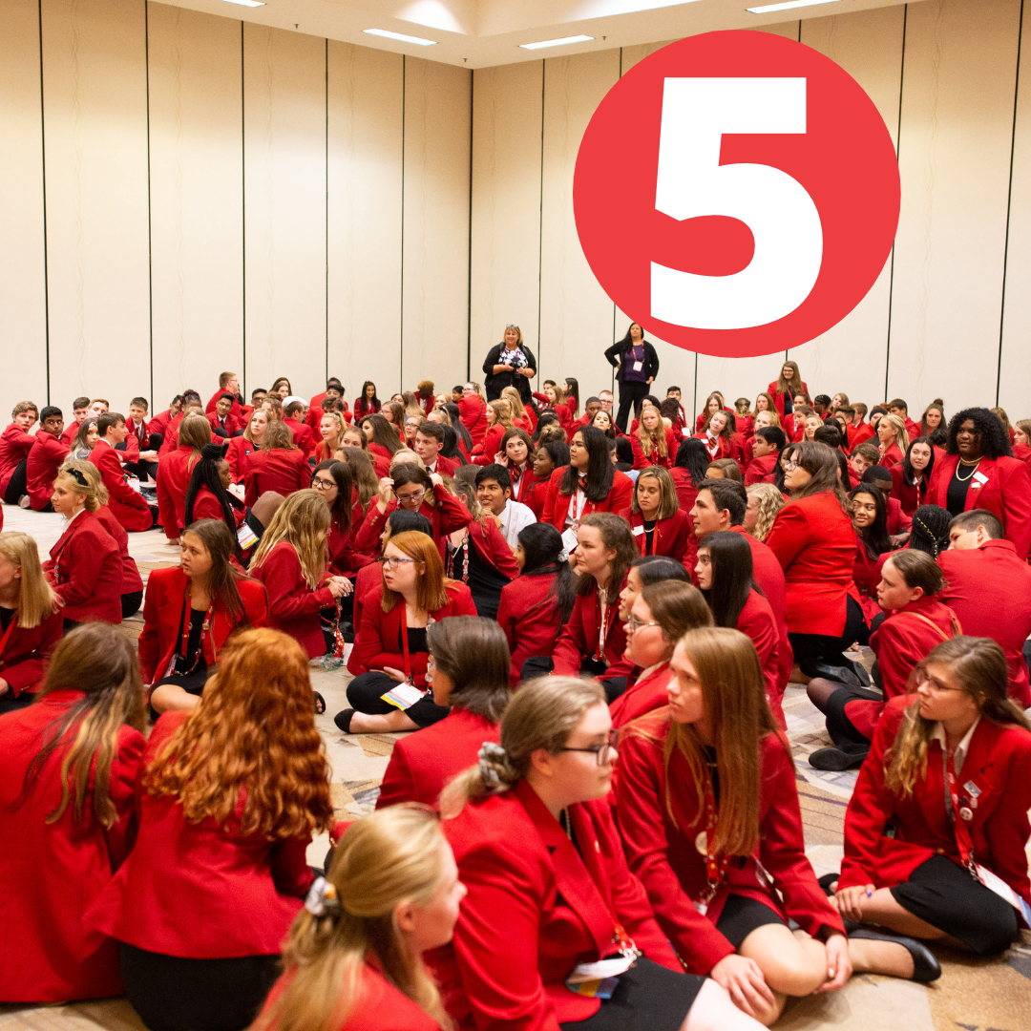

Reason #6 to Affiliate: Learn employability and real world skills!
What skills have you learned through being involved in FCCLA?

Reason #7 to Affiliate: Advocate for a cause or issue you believe in to make a positive difference in your community!
How do you plan on using FCCLA’s new National Program, Stand Up, to advocate Beyond Measure?
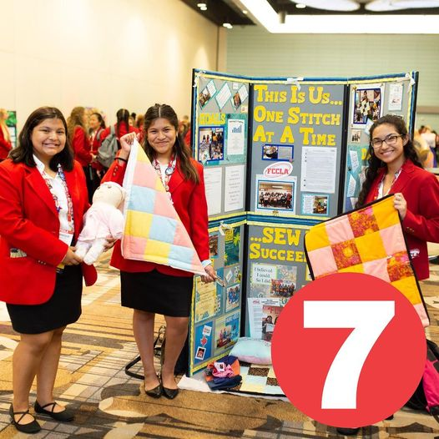

Reason #8 to Affiliate: Improve your family, career, and community through community service!
What has been your favorite community service project you have been involved in as a FCCLA member?
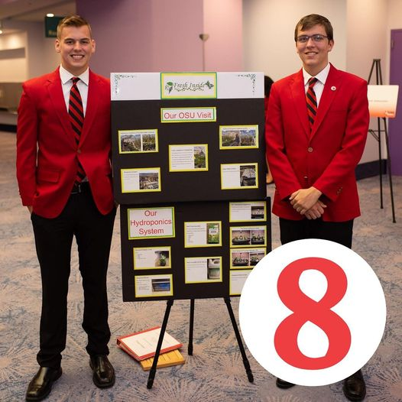

Reason #9 to Affiliate: Join the FCCLA family and become a part of a legacy of leaders!
Tag a leader that inspires you to go Beyond Measure!

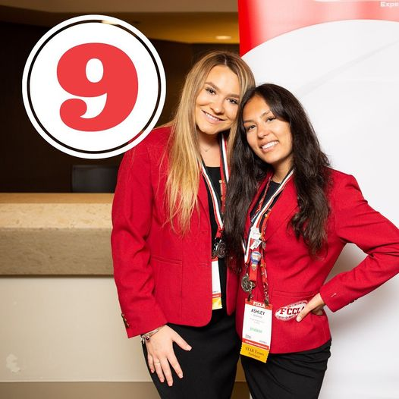

Reason #10 to Affiliate: Uncover your passion and reveal your purpose through Family and Consumer Sciences education!
How had FCCLA helped prepare you for your future career?

