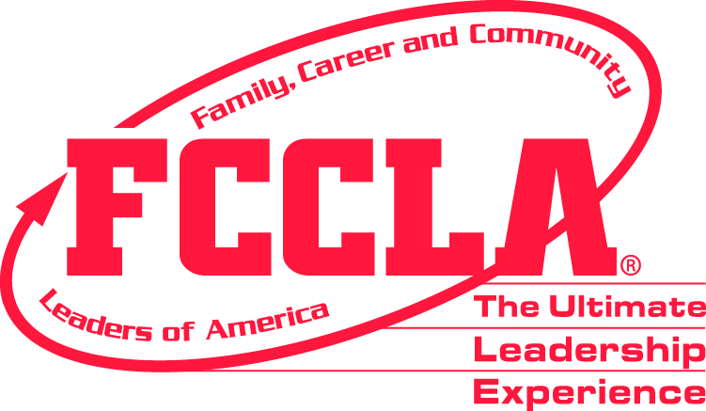
VIRGINIA ASSOCIATION
2026 State Leadership & Recognition Conference

April 23-25, 2004
DWill changes
April 10-12, 2026 ~ Virginia Beach Convention Center
(Some STAR Events competitions will be at the DoubleTree Hotel -Virginia Beach.)
Information Packet Contents

Advisers’ Opportunities page 8 &
and Chapter Development page 16
Agenda (Tentative Overview) page 14
Alumni & Associates Opportunities page 8
Awards, Ribbons & Recognition page 12
Banquet & Gala Event page 4
Conduct & Preparing Students page 9
Directions to Meeting Site/Hotels page 11
Discount for Package Registration page 2
Dress Code page 13 FCCLA Expo & FCCLA Shop page 9
Forms List page 2
General Sessions & Workshops page 9
Housing Options page 5-6
Health Related Policies page 2
Meals & Pizza Lunch Order page 4
Outreach Project page 6-7
Parking & Directions page 11
Registration & Rates page 2-3
Refund Policy page 4
Safety and SRO Free Attendance page 10
Special Needs page 9
STAR Events Participation page 10
Student Participant Opportunities:
Voting Delegates page 7
Hosts page 7
Be Connected Clothespin Game (new) page 8
Senior Spotlight page 8
FCCLA Game Day! page 7
Say Yes to FCS Signing page 8
2026 Special Activities Flyer page 15

IMPORTANT: This document does not include STAR Events entry information.
The entry process for students to participate in STAR Events is explained in the state rules found under the Competitions tab on the Virginia FCCLA website: virginiafccla.org Direct STAR Events questions to Deborah Will, Competitive Events Manager: (804) 364-2529 or debbiewillFCCLA@comcast.net



Please refer conference questions (not related to STAR Events) to Connie Rhoton:
Office: (276) 698-5154
Email: crhoton@mecc.edu

Chapter affiliation must be completed online with national FCCLA before beginning the conference/STAR Events registration process.

To get the best conference registration and STAR Events entry rates, complete conference registration online by Feb. 15.

To assure housing group rates and likelihood of room availability: email, postmark, or fax housing form to your selected hotel no later than Feb. 15.

Chapter affiliation must be completed online with national FCCLA before beginning the conference/STAR Events registration process. Feb. 15 is the affiliation deadline.

To get best registration rate, complete conference registration online by Feb. 15.

To assure housing group rates and likelihood of room availability, postmark or fax selected housing form no later than Feb. 15.

CONFERENCE PAYMENTS
Remember: Payments may be made by credit card online – Link to payment site
(also found in conference registration site)
Checks should be made payable to Virginia FCCLA Alumni & Associates and mailed to:
Virginia FCCLA Alumni & Associates
P.O. Box 1409
Gate City, VA 24251

REGISTRATION PROCESS
The process for registering for the conference is done online for any affiliated Virginia FCCLA chapter, using the “registermychapter” link provided on the State Conference page or the Competitions – State Rules page of the Virginia FCCLA website. This system allows advisers to register for the conference and enter members in STAR Events in one process. A total combined invoice will be generated. The site will open in mid-January.



MEETING LOCATION
The majority of activities for the conference will be at the Virginia Beach Convention Center. Certain STAR Events will be at the DoubleTree Hotel, which is adjacent to the convention center. The Baking & Pastry competitive event will be held at Tidewater Community College, with transportation provided for these participants.

HEALTH RELATED POLICIES FOR THE 2026 CONFERENCE
The Virginia FCCLA Board of Directors has mandated that health-related policies for Virginia FCCLA events will follow recommendations from the CDC, as well as policies in place by our Governor and Department of Education at the time of the event. Virginia FCCLA state staff will monitor recommended policies in the days prior to the conference and provide updates to advisers as needed. Advisers will be expected to enforce any policies put in place for the conference.

CONFERENCE FORMS (FOUND ON THE STATE CONFERENCE PAGE OF THE VIRGINIA FCCLA WEBSITE)
Conference and STAR Events registration are done online. There are additional forms advisers may use for specific conference activities or requirements. The forms listed below are available as downloads on the state conference page of the Virginia FCCLA website:

FORM | DUE DATE
Housing Reservation Forms (for all hotels holding rooms for FCCLA) – sent directly to the preferred hotel | Feb. 15 (reserve earlier if you have a definite hotel preference)
Student Medical Release & Code of Conduct (required) | March 25
Advisers’ Responsible Participation Acknowledgment (required) | March 25
Registration Refund Request | March 13 (March 23 for banquet)
Outreach Project Donation Form | March 10
Hosts Volunteer Form | March 10
Senior Spotlight Form | March 10
School Resource Officer Free Registration Form | March 10

REGISTRATION INFORMATION, FEES, AND REFUNDS
Fees, Due Dates & Onsite Hours
The conference registration fee includes program planning and materials, all general sessions, onsite projects, training sessions, and special activities. It does not include STAR Events entry fees, the Saturday “Banquet & Gala” event, or any other meals.

A Conference Registration Package is available that includes a discounted rate on basic conference options if choosing the package. Choosing the Package during online registration results in a savings of $30 per attendee over the individually-priced options and includes the Banquet & Gala on Saturday and a pizza lunch on Friday. STAR Events entry is a separate fee and not part of the package.
Non-Package Costs - through Feb. 15:  Registration - $130  Banquet / Gala - $44  **Friday Pizza Lunch - $16  SLRC T-Shirt - $15  Total: $205 | Package Pricing - through Feb. 15:  Registration -  Banquet / Gala -  Friday Pizza Lunch at VBCC -  Includes a free SLRC T-Shirt - $175
**Outside food may not be brought into the convention center. Concessions will be open on Friday with a la carte menu for those not purchasing the package option. A pre-purchased ticket for a pizza lunch at the VBCC is available for $16.

Affiliated Chapter Registration: All attendees from an affiliated FCCLA chapter (including chaperones, parents, and guests) will be registered by the adviser for the conference and for STAR Events in the online process that is linked to the chapter’s affiliation with national FCCLA. The conference registration link will be available on the Virginia FCCLA website around mid-January (www.virginiafccla.org ) – on both the State Conference page and the Competitions – State Rules page.
IMPORTANT POLICY: Chapter affiliation must be completed prior to beginning the conference/STAR Events registration process. To allow adequate time for affiliations to be updated and loaded into the conference /STAR Events system, chapter affiliation must be completed online with national FCCLA first – if you make changes to your affiliation, please alert Debbie Will so that those changes can also be imported into our conference registration site.

Registration for Non-Affiliated Attendees: We welcome “friends of FCCLA” who are not attending the conference as part of an affiliated chapter. These may include Alumni & Associates members, the Ruby Circle (retired advisers), college/university groups, or foundation donors. A separate registration form is available and can be sent via email, fax or postal service. Request this form by contacting:
Connie Rhoton at crhoton@mecc.edu; phone 276-698-5154 or Kathy Pierson at kpierson@mecc.edu

Online Registration Site Closes at midnight on Friday, March 27
After this time, onsite fees and registration go into effect. An on-site registration form for use by all affiliated and non-affiliated attendees will be available after March 27, on the state conference page of the Virginia FCCLA website or by contacting Kathy Pierson (contact information listed above).

Please be advised that conference registration and STAR Events entry fees will be charged at the registration rates in effect at the time the registration is submitted. For example, if you begin a registration prior to the February 15 rate period but submit the registration after that, you will be charged the higher rate per person.

Conference Rates (see separate rates and dates for STAR Events below)
Registration Submitted by February 15 = $130 per person; included if choosing the $175 Package option
Registration Submitted Feb. 16 – March 27 = $150 per person; included if choosing the $195 Package option
Onsite Registration (After March 27, deliver on site with advance approval by state staff) = $200 per person; $245 if choosing Package
Guest Day-Tripper Registration = $100 Friday or $75 Saturday. The day-tripper option is available for guests wishing to attend only one day of the conference and who are not FCCLA members or advisers. Members and advisers are expected to attend all conference sessions and pay the full conference registration fee.

Payment by credit card online (transactions are processed with a 3% service fee for all card payments) or a check payable to Virginia FCCLA must be received by March 1 or within two weeks of registration submission to avoid a late payment assessment of $50. Onsite Registration must be paid before conference packets are released.

IMPORTANT POLICY: If checks for conference fees are sent by individuals, rather than a school check, the FCCLA chapter will be responsible for payment if the check does not clear the bank, and must pay any additional bank fees charged to process the returned check.

Advisers may pick up conference packets in advance on Thursday evening, April 9, from 7:00 - 10:00 p.m. outside the Conference Headquarters in the Tower Café of the Virginia Beach Convention Center. Registration will take place from 8:00 a.m. - 6:00 p.m. on Friday, April 10. Day-tripper registration for conference guests only on Saturday is from 8:00 –10:00 a.m.

 STAR EVENTS REGISTRATION
Refer to the Competition section of the Virginia FCCLA website for information and related forms.
Prior to February 15 ~ affiliate all chapter members with the national FCCLA organization so that those student names will appear in the list for your conference registration; members must first be affiliated in order to register for STAR Events. Verify accuracy of spelling and grade level for each member competing.
By February 15 ~ $30 per participant; NOTE: some STAR Events will reach maximum capacity and may be closed after February 15 – register early to ensure your spot!
February 16 – March 6 ~ $60 per participant
March 7 to final cut-off ~ $100 per participant
INCENTIVES FROM THE 2025-26 MEMBERSHIP PACKAGES
Incentives related to state conference registration were part of the special 2025-2026 membership packages. Advisers affiliating under either the Up to 25 Package or the Unlimited Package should email Deborah Will after completing the online conference/STAR registration to have those incentive discounts applied and an updated invoice created.

Refund Policy
Registration fee refunds will be honored, less a per person handling fee, if the request is received in writing on the Refund Request Form (download from the SLRC page of the website) by March 13. Requests for refunds will not be accepted over the telephone or by email unless the Refund Request Form is attached.

Refunds for the “Banquet & Gala” event will be honored, less a per person handling fee, if request is received in writing on the Refund Request Form by March 23.

STAR Event registration fees are not refundable.

Guests
There is no limit to the number of conference participants. We encourage chapters to bring as many delegates as possible. Advisers, members, Alumni & Associates, chaperones and guests of your local chapter are invited to attend. We strongly encourage chapters to invite school administrators and guidance counselors to participate in the conference. Your chapter’s guests are also needed as STAR Events volunteers! Please note that all members, advisers, chaperones, and other guests of your chapter must pay conference registration fees in order to attend general sessions, workshops, and special events. A day-tripper rate is available for guests wishing to attend only one day of the conference weekend.

BANQUET AND GALA EVENT
On Saturday evening, conference participants may choose to attend a themed banquet session, followed by a gala featuring dancing, activities, and refreshments. This is a festive event designed to offer a unique “formal affair” experience for the students. We provide extra security throughout the evening. The cost of the banquet/gala is $44 per person. It is included in the Conference Package Option. Those wishing to participate in the Banquet & Gala should register for this event during the online conference registration process. After March 27, register for the banquet using the onsite registration form that will be available on the state conference page of the Virginia FCCLA website or by contacting Kathy Pierson at kpierson@mecc.edu

Dress for the Banquet & Gala is formal or semi-formal. No jeans are allowed. Advisers are expected to enforce this policy. Refer to the Virginia FCCLA Dress Code for details, including appropriate guidelines for evening gowns and dresses. A short slide show on appropriate Banquet & Gala attire is on the Virginia FCCLA website (state conference page). Seating for the Banquet & Gala will be assigned as advisers pick up conference packets.

MEALS
There are no meals included in the registration fee, unless the Conference Registration Package option is selected. The Saturday evening banquet/gala event is optional and is described above. The Doubletree Virginia Beach has a restaurant and may offer lunch specials. The Virginia Beach Convention Center typically has concessions open with a limited number of options. IMPORTANT REMINDER: The Virginia Beach Convention Center has a strict policy regarding bringing food from outside vendors into the convention center. Only food items purchased from the convention center food venues may be consumed inside the building. FCCLA attendees who bring food from outside vendors into the building will be asked to leave.

Again This Year: Pre-Order Pizza Lunch at the VBCC – Friday During Conference!
For those not taking advantage of the Conference Registration Package, Virginia FCCLA is offering the option of pre-ordering a pizza lunch for your students and paying for these in advance through our online conference registration site. The cost is $16 per person and includes two large slices of pizza (several varieties available), a dessert snack, and a soda or water. The pizza lunch is included as part of the Conference Registration Package, so advisers registering under the package should not mark this option. A place is provided in the online conference registration to indicate the number of pizza lunches ordered if you are not doing the package. Lunch tickets will be in the advisers’ registration packet to distribute to those participating.
HOUSING OPTIONS FOR THE 2026 STATE CONFERENCE

IMPORTANT REMINDER: Please use the Housing Reservation forms provided on the state conference page of our Virginia FCCLA website in order to get the conference rates guaranteed until Feb. 15. It is very important that attendees use the listed hotels since they have partnered with our organization to hold rooms for us through the reservation deadline. Some hotels may take reservations after the deadline if blocks are not filled but advisers are urged to make reservations early in order to get your preferred hotel.
Four housing options have rooms that can sleep six. Nine properties offer free bus parking with advance notice due to limited number of spaces. The “advantages” listed below are based on site visits by Connie Rhoton and Bobbi Comer in September.

On-Site Headquarters Hotel: DoubleTree by Hilton - Virginia Beach CLOSEST HOTEL TO VBCC
1900 Pavilion Drive - Virginia Beach, VA 23451 Phone: (757) 422-8900 FAX: (757) 422-0039
Email reservation form to: mwilson@doubletreevb.com
Rate: $154 = $179.10 inclusive with all taxes; NOTE: 7-day cancellation policy; 3-night minimum 175 rooms in FCCLA block
ADVANTAGES: Short walking distance to the convention center; some STAR Events are held here; free bus parking

Oceanfront Hotel: The Capes BEST RATE FOR OCEANFRONT
2001 Atlantic Ave - Virginia Beach, VA 23451 Phone: (757) 428-5421 Email reservation to: sales@pashmglobal.com
Rate: $129 = $150.35 inclusive with all taxes for room with 2 double beds free bus parking off-site
Rate: $169 = $196.35 inclusive with all taxes for suite with three double beds – can sleep six 15 rooms in FCCLA block
ADVANTAGES: Smaller, well-established hotel; quieter atmosphere; very clean and well maintained for an older property

Oceanfront Studio Suites Hotel: Comfort Suites Beachfront BEST RATE FOR SIX IN A ROOM
2321 Atlantic Ave - Virginia Beach, VA 23451 Phone: (757) 491-2400 or (757) 407-4509 Email to: sales@pashmglobal.com
Rate: $145 = $168.75 inclusive with all taxes for Doubles Suite with 2 double beds, sleeper sofa in separate room – can sleep six
NOTE: King Suites have king bed, sleeper sofa in separate room – can sleep four; free bus parking off-site 20 rooms in FCCLA block
ADVANTAGES: Best rate for six in a room; very good breakfast that includes several hot items

Oceanfront Hotel: Country Inn & Suites CENTRAL LOCATION ON OCEANFRONT
1901 Atlantic Ave - Virginia Beach, VA 23451 Phone: (757) 437-9100 ext. 7101 Email form to: pstith@landmarkhg.com
Rate: $165 = $191.75 inclusive with all taxes for room with two beds and a sleeper sofa – can sleep six 30 rooms in FCCLA block
ADVANTAGES: Excellent rate for six in a room; closest of that room type to the VBCC

Oceanfront Hotel: Fairfield Inn & Suites by Marriott CENTRAL LOCATION ON OCEANFRONT
1801 Atlantic Ave - Virginia Beach, VA 23451 Phone: (757) 383-6065 FAX: (757) 417-4983 Email reservation to: afuller@coastalha.com
Rate: $154 = $179.10 inclusive with all taxes for all room types (double/doubles or one king) 25 rooms in FCCLA block
ADVANTAGES: Closest oceanfront hotel to the VBCC; directions provided for free bus parking off-site

Oceanfront Hotel: Hampton Inn North Oceanfront NEW TO VA FCCLA IN 2026
3107 Atlantic Ave, Virginia Beach, VA 23451 Phone: (757) 213-2332 Email form to: casey.burnett@shaminhotels.com
Rate: $179 = $207.85 inclusive with all taxes for room with two queen beds 20 rooms in FCCLA block
ADVANTAGES: Free breakfast; free bus parking (advance notice)

Oceanfront Hotel: Hampton Inn South Oceanfront TWO-NIGHT STAY IS ALLOWED
1101 Atlantic Ave - Virginia Beach, VA 23451 Phone: (757) 965-2300 Email form to: mgavano@HarrisonGP.com
Rate: $169 = $196.35 inclusive with all taxes for room with two queen beds 15 rooms in FCCLA block
ADVANTAGES: Two-night minimum stay is allowed; free hot breakfast; free bus parking (advance notice)

Oceanfront Hotel: Holiday Inn Express LARGEST OCEANFRONT BLOCK OF ROOMS
2607 Atlantic Ave - Virginia Beach, VA 23451 Phone: (757) 491-6900 FAX: (757) 491-2125
Email form to: mbarnes@hiexpressvb.com
Rate: $149 = $173.35 inclusive with all taxes for all room types (double/doubles or one king) 50 rooms in FCCLA block
ADVANTAGES: Largest oceanfront block for FCCLA; good rate from our longest running hotel partner free bus parking

Oceanfront Hotel: Sandcastle Resort VERY GOOD RATE FOR OCEANFRONT
1307 Atlantic Ave - Virginia Beach, VA 23451 Phone: (757) 428-2828 FAX: (757) 422-3184 Email reservation to: sales@pashmglobal.com
Rate: $139 = $161.85 inclusive with all taxes for room with 2 double beds 25 rooms in FCCLA block
ADVANTAGES: Reservation date extends to Feb. 20 (may be later based on availability); free bus parking (advance notice)

Oceanfront Studio Suites Hotel: SpringHill Suites FULL HOT BREAKFAST
901 Atlantic Ave - Virginia Beach, VA 23451 Phone: (757) 383-6065 FAX: (757) 417-4983
Email reservation to: afuller@coastalha.com
Rate: $154 = $179.10 inclusive with all taxes for Queen Studio Suites – can sleep six 30 rooms in FCCLA block
ADVANTAGES: Very good rate for six in a room; sleeper sofa in separate nook; full hot breakfast
“Away from the Crowd” Oceanfront Hotel: Wyndham Virginia Beach Oceanfront BEST RATE FOR OCEANFRONT - NEW TO VA FCCLA IN 2026 – This oceanfront property is in the northern part of the beach area, a short distance beyond the Cavalier Hotel complex. It is a quieter, less congested neighborhood and still less than a 10-minute drive to the VBCC. (Used for the VATFACS Institute in July 2025.)
5700 Atlantic Ave - Virginia Beach, VA 23451 Phone: (757) 4428-7025. Email reservation to: jzito@WYNDHAMVB.COM
Rate: $129 = $150.35 inclusive with all taxes for room with two beds 50 rooms in FCCLA block
ADVANTAGES: Quieter area with full oceanfront views; allows two-night stay; restaurant onsite free bus parking

Housing Reservation Instructions
Use the specific Housing Reservation Form designated for each of the hotels. Page 2 of the form is designed for use with all hotels and is the portion of the form which provides critical information as to the type of room and the names of the occupants. All housing forms are found in the Housing Reservation Forms file to be downloaded from the state conference page of the Virginia FCCLA website.

Housing forms must be postmarked or faxed by Feb. 15 to the selected hotel to assure rates. No additional discounts may be applied to the conference rates. Certain hotels have extended the reservation deadline. Check the specific housing form to verify the deadline.

STUDENT PARTICIPATION OPPORTUNITIES
Voting Delegates
The Virginia FCCLA Board of Directors has proposed a change in the number of voting delegates a chapter will have. They recommend that chapters shall be allowed the following number of voting delegates:
1—49 members = 1 voting delegate
50—99 members = 2 voting delegates
100—149 members = 3 voting delegates
150+ members = 4 voting delegates

Chapters affiliating with national FCCLA’s Middle Level Option will have 2 voting delegates; those affiliating with the national Unlimited package will receive 4 voting delegates.

Because voting on bylaws revisions will occur prior to the officer elections, the section of the current bylaws regarding the number of voting delegates has been set aside for the 2026 conference and the above list will be used.

Voting delegates will be required to attend the Saturday morning Business Session, sit in the reserved section, and vote on Virginia Association of Family, Career and Community Leaders of America business.

Voting delegates are voting representatives of their chapters. They will vote on state officer candidates and on any proposed bylaws changes. Proposed bylaws changes will be posted on the Bylaws section of the state website prior to the conference. Officer candidate information will be distributed to advisers in their conference packets. Since the entire chapter may not have the opportunity to review the officer candidate information, voting delegates should be selected to represent the views of the entire chapter.
General Session or Workshop Hosts
Chapters may select a member to serve as a host for general sessions and workshops. Host responsibilities include handing out meeting materials and assisting workshop presenters as needed. Hosts will be assigned to a specific session during an orientation meeting at 4:00 – 4:30 p.m. Friday, April 4 at the Virginia Beach Convention Center – location to be announced. Complete the downloadable form on the state conference page of the Virginia FCCLA website - Hosts form. The position of “host” is different from that of “STAR Attendant/Helper”.

SPECIAL 2026 EVENT
FCCLA Game Day (scheduled for Friday – check conference program for exact times)
Students will have time to network and relax while enjoying a selection of games and tournaments throughout the day on Friday. Many board games will be available for play throughout the day. The following tournaments are scheduled with prizes for the tournament winners: Connect 4, UNO, Spoons, Hungry Hippos, and Cornhole Toss.
Details and tournament times will be listed in the conference printed program.

2026 CONFERENCE OUTREACH PROJECT:
HumanKind – A Nonprofit Organization Headquartered in Lynchburg, VA
Involvement in community service outreach is an important conference tradition. For many years, Virginia FCCLA has collected donations to assist families, communities, or chapters that have suffered from disasters or have emergency needs.
This year, the officers chose HumanKind, a nonprofit headquartered in Lynchburg, VA, with offices across the state. HumanKind supports local families facing challenges related to poverty and works to strengthen individuals, families, and communities through care, counseling, and education. Programs include an Economic Resource Center, Healthy Families, Early Head Start, and Foster Care services.
Their mission is to strengthen individuals, families and communities through care, counseling and education. We ask that each chapter attending the conference help by making a monetary donation that will be used for this statewide effort.
During the FCCLA Expo on Friday, conference attendees may enjoy a “Candy Salad Bar” where, for a small fee, they create a mixture of favorite sweet snacks. The profits from this will be donated to the HumanKind organization.
Chapters must complete the Virginia Outreach Donation Form (found with the SLRC Forms downloads) and send to Connie Rhoton by March 10, indicating your chapter’s participation in this project and identify the amount you plan to donate. All contributing chapters will receive a certificate during the Opening Session of the conference as a representative goes onstage to present the check or indicate that a contribution was sent in advance. The chapter donating the most money and completing the donation form will receive a special entrance and priority seating at the Opening Session.
NEW! Be CONNECTED In the Virginia FCCLA Clothespin Game
FCCLA members attending the 2026 conference are invited to bring up to five clothespins, decorated with their chapter name and creative artwork. Throughout the conference, when you observe another member exhibiting positive attitudes such as kindness, friendliness, and helpfulness, show your respect for their behavior by making a clothespin connection! Clip a clothespin on them! The “most connected” members, based on the number of clothespins they collect, will be recognized at the Closing Session on Sunday morning.
At the Expo on Friday, Alumni & Associates will be selling packs of 5 clothespins and will have a variety of art supplies for decorating them. Proceeds from the clothespin sales will be added to the conference Outreach Project donations to the Humankind organization.

VIRGINIA FCCLA IMAGE AWARD AND SPIRIT OF FCCLA RECOGNITION
Virginia FCCLA will recognize one chapter at the conference for the professional image and conduct demonstrated by their attendees. The members of our Alumni & Associates Executive Board will be observing behavior and compliance with the Virginia FCCLA dress code throughout the weekend and will select one chapter who exemplifies high standards in appearance, courtesy, attitude, and helpfulness. Each state officer will select an individual Virginia member to receive a Spirit of FCCLA certificate for exhibiting attitudes reflective of the mission of our organization. These awards will be presented on stage during the Closing Session.

VIRGINIA FCCLA SENIOR SPOTLIGHT
On Sunday morning just prior to the Closing Session, we invite chapters to recognize their outstanding senior members through a “Senior Spotlight.” Each chapter adviser may select up to three deserving senior members, who will be attending the 2026 state conference, to be featured on a slide highlighting their FCCLA involvement. A form (found with the SLRC Forms downloads) must be completed for the selected senior/s. Email the form, with up to two digital photos of the senior member, to Bobbi Comer by March 10.

“SAY YES TO FCS” SIGNING CEREMONY
Virginia FCCLA is proud to participate again in the national recruitment effort called “Say Yes to FCS.” The purpose of this initiative is to encourage our students to choose a career in Family and Consumer Sciences, especially in education, with a goal of being an FCS teacher and FCCLA adviser. Chapter advisers are asked to assist us in identifying your seniors who plan to major in FCS education in the fall of 2026 so we can have a “signing ceremony” on stage at the conference – advisers will be able to list these students’ names in your online conference registration site so that they can receive a special invitation to our signing ceremony. We will also include seniors entered in the Say Yes to FCS Education STAR Event. Arrangements and instructions will be provided prior to the conference to advisers who sign up eligible members. Advisers to those members will receive our Teacher of Teachers Award!

ADVISER OPPORTUNITIES
Special activities for advisers are scheduled throughout the weekend, aimed at strengthening skills as a chapter adviser and gaining a deeper understanding of ways to incorporate FCCLA as an intra-curricular part of FCS courses. A detailed listing of adviser opportunities is on page 16.
ALUMNI & ASSOCIATES OPPORTUNITIES
We warmly invite all Alumni & Associates members and former chapter advisers to participate in the conference. A conference registration form is available by contacting Connie Rhoton (crhoton@mecc.edu). Activities of special interest to A&A members include:
- Evaluate STAR Events on Friday. Contact Deborah Will (debbiewillFCCLA@comcast.net) to volunteer.
- Conference assistance – A&A members interested in assisting with the FCCLA Shop, registration, or other activities may volunteer by contacting Jamie Pearce at jamie.carr.1102@gmail.com
- “Banquet & Gala” event on Saturday evening at 6:30 p.m. The cost is $44 per person. Please register and pay in advance using the conference registration form.
LEADERSHIP FOUNDATION SUPPORT
Chapters are encouraged to make contributions to the Virginia FCCLA Leadership Foundation, which has been established to provide support and sponsorship for FCCLA leadership activities in our state. For your convenience, there is an opportunity to indicate a chapter donation within your online conference registration. Individuals or chapters with associated giving of $100 or more, and providing the contribution is received by March 1, will receive a ribbon for their conference name badge. Please note: This donation is separate from the Outreach Project donation made on stage during the Opening Session.

GENERAL SESSIONS AND WORKSHOPS
OPENING SESSION (including special interactive event) – Theme presentations, program awards, and lots of audience participation will make this session entertaining as well as informative. During the Opening Session, attendees will be challenged to THINK FAST in an interactive event sponsored by the Virginia FCCLA Leadership Foundation.
BUSINESS SESSION – Voting delegates must attend this session where important decisions regarding the yearly operations of our association will be discussed. Other members and advisers are encouraged to attend. Membership awards will be announced during the Business Session.
WORKSHOPS – Saturday morning following the keynote session, members may choose from a wide variety of workshops focusing on career pathways, FCCLA national programs, and personal growth. A special session is planned for advisers.
CLOSING RECOGNITION SESSION – On Sunday morning, a Closing Session will include installation of new state officers, FCCLA individual program awards, and awarding of all STAR Events medals, scholarships, and trophies.

FCCLA EXPO
A special feature of the conference is the FCCLA Expo. The expo will have booths from several colleges and FCS-related post-secondary programs, including culinary schools. Students will have the opportunity to “Say Yes to FCS” with detailed information and activities related to careers in Family & Consumer Sciences from participating colleges and universities.
Fundraising ideas, FCCLA national program project activities, games, and more make the Expo a place to network with other members from across the state. The FCCLA Expo is planned for Friday, with some activities beginning at 9:30 a.m.

THE FCCLA SHOP (WITH LOGO ITEMS)
FCCLA items, ideal for use as gifts for students, school administrators, and other supporters of your FCCLA chapter, will be available at The FCCLA Shop during the conference. These items are a great way to promote FCCLA and create a public relations campaign.

SPECIAL NEEDS
If a person with a disability is attending the conference and desires any assistive devices, services, or other accommodations to participate in the activities, please contact Connie Rhoton at crhoton@mecc.edu by March 1 to discuss accommodations.
PREPARING STUDENTS AND STUDENT CONDUCT
It is the adviser’s responsibility to adequately discuss appropriate conduct and dress with all of the chapter’s SLRC delegates – this includes adherence to and enforcement of our dress code, “no jeans” policy, and any health-related mandates. Each delegate is to read the Virginia FCCLA Dress Code and the Code of Conduct and student delegates must sign in the space provided on the Student Medical Release and Code of Conduct form. Medical forms must be completed for each student. Forms may be scanned and emailed to crhoton@mecc.edu; or faxed to 276-386-7454; or mailed to Connie Rhoton - P.O. Box 1409 – Gate City, VA 24251
IMPORTANT NOTE: If medical release forms are not completed by the deadline for conference registration payment, please mail or fax them no later than March 25.

Conference packets will not be released to the chapter adviser until a medical form is on file for each student.

Advisers are also asked to remind the student that this is an “educational” weekend, not just “party-time” at the beach. General sessions are scheduled for approximately 1½ to 2 hours and contain educational content as well as entertainment. Students are expected to participate in the FCCLA Expo, and in the Friday and Saturday leadership sessions (workshops). Adequate relaxation time “at the beach” is scheduled for Saturday afternoon but students need to understand that the educational activities of the conference are a first priority.
Conference activities are scheduled into the late evening on Friday and Saturday nights. We strongly encourage advisers and chaperones to keep the students involved in the scheduled sessions and activities, including the Banquet and Gala. Unsupervised time in the hotel can lead to problem behavior. Too much “free time” often results in discipline issues. Keeping students busy in supervised activities/sessions, especially in the evenings, reduces negative behavior.

REQUIRED: Advisers’ Responsible Participation Acknowledgment Form
In an effort to emphasize the importance of involving students in all scheduled conference activities and reducing opportunities for inappropriate behavior, chapter advisers must acknowledge their responsibility in making certain that all delegates from the chapter participate in all of the scheduled conference activities. Advisers who allow students to skip or leave sessions/activities early are putting students in higher risk situations and must assume complete responsibility for such decisions. Conference registration packets, including STAR Events packets, will not be released until the form, signed by the adviser and principal, has been submitted. For smooth packet pick-up, it should be sent by March 25 with the Student Medical Release and Code of Conduct forms

STAR EVENTS PARTICIPATION
Participants in STAR Events (including both state and national events) will compete in-person Friday, April 10. Participation in STAR Events requires advance registration and an entry fee, completed online by Feb. 15 for best rates and event availability. Advisers’ onsite STAR Events/Conference packet pick-up will take place from 7:00 – 10:00 p.m. on Thursday evening and on Friday morning from 7:15-8:00 a.m. Information about STAR Events is available on the Competition page of the Virginia FCCLA website or by contacting Deborah Will at (804) 364-2529; debbiewillFCCLA@comcast.net.

CHAPTER MEMBERS NOT INVOLVED IN STAR EVENTS
We encourage members not entered in STAR Events to participate in one of the following:
- Serve as a Student STAR Events Evaluator. A download of the evaluator application is on the STAR Events section of the website – see Volunteer Forms. Please also refer to the “General Information” download file, for the student STAR Events evaluator criteria and additional copy of the application.
- Serve as a STAR Attendant/Helper. Assist the STAR Events room consultant in event management. An application form for STAR Attendant/Helper is located in the Volunteer Forms download and in the “General Information” STAR Events download file on the Virginia FCCLA website. STAR Attendants must plan to work for the duration of their assigned event.
- Student volunteers may also be identified in your online conference registration.

SECURITY AND SAFETY
The safety and security of our attendees is the top priority as we plan a weekend that is filled with learning opportunities, networking, and fun for our members. Each hotel is asked to provide security officers on their property for the weekend. Virginia FCCLA supplements this by hiring additional police officers to patrol all FCCLA activities on both Friday and Saturday nights of the conference.

As an additional precaution, we schedule programmed sessions, speakers, and supervised activities for the students up until thirty minutes prior to curfew on Friday and Saturday nights. We realize that the best way to reduce behavioral problems is to keep students busy in organized activities. We highly recommend that advisers require students to participate in the scheduled evening events, including the Saturday evening Banquet & Gala, rather than returning early to the hotels.

Free Registration and Meals Offer for School Resource Officers
The safety and security of our conference attendees is always the highest priority for Virginia FCCLA. We follow the National Association of Secondary School Principals’ guidelines of having a 15:1 ratio of students to advisers/chaperones for high school groups and a 12:1 ratio for middle school groups. In addition, we welcome School Resource Officers (SRO) willing to serve as chaperones. We believe having these trained officers in attendance gives additional support to the security officers provided by the state association.

If an SRO is attending the conference, and is willing to assist in monitoring hotel hallways in the evenings and providing security support to conference attendees during sessions and competitions, Virginia FCCLA will waive all registration fees and provide a complimentary ticket to both the Awards Banquet on Saturday evening, and the pizza lunch on Friday.

In order to register your SRO to participate in the conference, please complete the School Resource Officer form on the state conference page of our website. A name badge, pizza lunch ticket, and banquet ticket for the officer will be included in the adviser’s conference packet, picked up during the on-site registration. You do not need to list the SRO in your conference registration site. The form is returned to Connie Rhoton and may be shared with Kathleen Buchanan, who may reach out to the registered SRO for assistance in a conference workshop as well.

DIRECTIONS TO VIRGINIA BEACH CONVENTION CENTER AND CONFERENCE HOTELS
For the Convention Center and the DoubleTree Hotel: When approaching the Virginia Beach area, use I-264 East toward the resort area. Take Exit #22 (Birdneck Road) off of I-264 East.
For the Convention Center, turn right at the end of the exit ramp, then make an immediate left on to 19th Street. The VBCC will be approximately a quarter of a mile on the left with parking on both sides of 19th Street.
For the DoubleTree Hotel, at the end of the exit ramp, go straight through the light onto Pavilion Drive. The entrance to the Doubletree Virginia Beach will be on the immediate left.

All other conference hotels, follow I-264 until it ends, then proceed to Atlantic Avenue. Turn right for hotels on the 21st block and lower. Turn left for the 22nd block and higher.

Parking:
Automobile parking is available at all hotels and at the convention center.

Bus parking at the Virginia Beach Convention Center will be restricted to a designated area along the access road between the convention center and the DoubleTree Hotel parking lot. Directions to this area will be available at conference packet pick-up.

Please refer to Pages 5 & 6 of this document to identify those hotels in the FCCLA contract that provide free bus parking. All of these hotels require advanced notice regarding the need for a bus parking space. This should be indicated in the designated box on the hotel reservation form (found on the state conference page of the Virginia FCCLA website).

AWARDS, BADGE RIBBONS, AND RECOGNITION INFORMATION

VIRGINIA CHAPTERS COMPLETING PROGRAM AWARD APPLICATIONS
IMPORTANT REMINDER
The applications for national program awards are connected to the chapter affiliation portal.
To apply for a National Program Award please follow the steps below:
1. Log on to your chapter's affiliation portal
2. Once logged in, select the “Program Awards” tab
3. Select whichever award section you wish to apply for (“Program Award Application” for consideration for national recognition or “Project Summary Only” for a shorter process – do not complete both)
4. Select “Apply Now” for either Middle or High School to start entering information
IN ORDER TO RECEIVE RECOGNITION AT THE STATE CONFERENCE (certificates, plaques, trophies, and program ribbons for the name badge): CONFERENCE REGISTRATION MUST BE COMPLETED NO LATER THAN MARCH 5.

Ribbons and other awards will be ordered by that date and supplies will not be available for chapters registering after the order date.

Early registration fees apply to all registrations completed before February 15.

All state conference recognition is based on the following procedures:
- Award applications for all FCCLA programs (Career Connection, Community Service, Families First, FACTS, Financial Fitness, Power of One*, Stand Up, and Student Body) must be completed and submitted online through your chapter affiliation portal by 5:00 p.m. March 1. (On the national website click Programs; then click Awards. See steps above.)
- A photo from the project PLUS a screenshot of your favorite social media post, in digital format, must be uploaded to the following Google folder. Instructions are included in the link.
2026 National Programs Photos
*If you are unable to use Google Drive, photos may be emailed to bcomer@mecc.edu. Please ensure that photos are in .jpg, .jpeg, or .png format and files are small enough to be emailed.

- The award checklist for Outstanding Chapter must be completed online by March 5. Visit the Outstanding Chapter page under Programs and Awards on the Virginia FCCLA website for a link to this Google doc.
- The chapter’s initial conference registration must be entered by March 5 so that ribbons and awards can be ordered. NOTE: Early registration fees apply to all registrations submitted before February 15.

Membership recognition information is found on the website under “Membership – Membership Recognition.” Chapters must meet the March 1 affiliation postmark deadline and be in attendance at the conference to qualify for membership recognition.
Continued for 2026: “Go for the Red” National Membership Award
In support of the national FCCLA “Go for the Red” membership campaign, those who complete the individual and chapter membership award on the National FCCLA website by March 1 will be recognized at the state conference during the Business Session.

Virginia FCCLA Dress Code revised: September 2022

FCCLA is one of the career-technical student organizations sponsored by the Department of Education for the purpose of preparing youth for career success. Specifically, FCCLA prepares students for the multiple roles of family member, wage earner, and community leader. Therefore, an important part of the educational experiences provided by FCCLA includes developing an understanding of appropriate behavior and dress for business meetings and functions.
Please note that the national FCCLA organization has a dress code policy for all events and activities at the national level that must be followed for the National Leadership Conference, National Fall Conference, Capitol Leadership, and national competitive events. Please check the national website (www.fcclainc.org) for a copy of their dress code.

The Dress Code provided here is for events sponsored by Virginia FCCLA. Appropriate mitigation strategies, including face masks, may be required for a specific event as determined by the Board of Directors.
Type of Event (Examples) | Examples of Appropriate Attire
Business Casual:  State conference sessions and workshops; STAR Events recognition; STAR Events presentations unless the specific event rules allow chef attire | - Business-style shirt such as a polo, button-up, shell, blouse, or sweater with  optional neck tie, scarf, or professional neckwear  - Business-style pants, skirts, or dresses at or below the knee in length (due to the active nature of many of our events, wearing pants is strongly encouraged)  - Business-style shoes (non-athletic)  - No denim is allowed in any article of business casual attire
Professional:  Meetings with community or business leaders and other functions when representing FCCLA in an official capacity; FCCLA banquet and gala | - Professional suit with professional shirt/blouse; optional professional neckwear  - Professional jacket with a dress shirt/blouse and dress pants or a skirt/dress (no denim)  - Professional shirt with neck tie, scarf, or professional neckwear;  dress pants or skirt (at or below the knee in length)  - Dress shoes (non-athletic)  - No denim is allowed in any article of professional attire
Formal Attire:  FCCLA conference banquet and gala | - Professional/business attire listed above or tuxedo  - Formal or semi-formal dress with straps (at or below the knee in length); no visible cleavage; no bare back below the waist may be showing)  - No denim is allowed in any article of formal attire
Casual:  Travel to and from FCCLA functions, recreational tours, theme parks, the State Fair, and similar casual activities | - Longer-length shorts (at the knee preferred)  - Neat pants (e.g. jeans or athletic/yoga wear with no holes or frayed edges)  - T-shirts or other casual shirts (no inappropriate language or graphics)  - Casual or athletic-style jackets  - Casual or athletic footwear
Pool Attire:  Pertains to national meeting functions when swimming is permitted | - Conservative swimsuit (one-piece or moderately cut two-piece)  - Bathing suit cover and shoes must be worn to and from pool area  - No speedos, skimpy bikinis, or thong-type bathing suits | Note: Swimming is not permitted during the state conference.

Always Appropriate Attire:
The official FCCLA uniform jacket and neckwear are available through the national FCCLA supplier(s). They are not required for Virginia FCCLA events but are always appropriate.

Always Inappropriate Attire:
The following should not be worn to any FCCLA activity, including in the hotel hallways and lobby:
- Clothing or accessories which are sexually suggestive, advertise drugs, alcohol, or tobacco products, or display profanity
- Spaghetti straps; strapless or low-cut blouses/shirts/dresses, see-through or tight-fitting clothing
- Skirt, dress, or shorts that are above the knee while standing
- Pants or skirts which are worn below the hip bone; no undergarments may be showing
- Spandex, short shorts, cutoffs, or pajamas
- Clothing which is stained, torn, or ripped
Remember, the image of FCCLA depends on the professional behavior and appearance of its members.

- Flip-flops, except with casual or pool attire
- Bare feet

TENTATIVE AGENDA
2026
VIRGINIA FCCLA STATE LEADERSHIP & RECOGNITION CONFERENCE
Times and activities may change – see the printed conference program available at registration to confirm.

DATE/TIME ACTIVITY

THURSDAY, April 9
7:00 pm – 10:00 pm Conference/STAR Events Packet Pick-up with
Networking Activities for Members
TBA State Officer Candidates’ Complete Knowledge Form
8:00 pm – 9:00 pm STAR Events Lead & Room Consultants Meeting
FRIDAY, APRIL 10
7:15 am – 8:00 am STAR Events/Conference Packet Pick-up
8:00 am – 6:00 pm Conference Packet Pick-up & On-Site Registration
7:45 am – 8:15 am STAR Attendants/Helpers Orientation
8:00 am – 9:15 am Evaluators’ Check-in & Orientation
8:00 am – 9:00 am Set-up for state exhibit STAR Events
9:15 am – 5:30 pm STAR EVENTS (note that the Baking & Pastry competition will be held at Tidewater Community College with transportation provided)
9:30 am – 6:00 pm The FCCLA Shop
9:30 am – 3:30 pm FCCLA Expo Exhibits and Activities Open
10:00 am – 3:30 pm FCCLA Game Day Activities – continuous admission
11:00 am – 1:00 pm Pizza Lunch Pick-Up (pre-purchased ticket) or Lunch on Your Own
3:15 pm – 4:15 pm Officer Candidates Orientation
4:00 pm – 4:30 pm Hosts Meeting
Until 7:30 pm Dinner on Your Own
7:30 pm Doors Open for Photos in the Conference Theme Sets
8:00 pm – 10:45 pm OPENING GENERAL SESSION (includes THINK FAST)

SATURDAY, APRIL 11
8:00 am – 10:00 am Conference Guests Registration
8:30 am – 9:45 am BUSINESS SESSION
10:00 am – 11:45 am Leadership Action Sessions (two rotations)
11:15 am – 3:00 pm Officers-elect Interviews & Training Session
12:00 pm – 5:00 pm Lunch & Local Touring on Your Own
6:30 pm – 9:15 pm BANQUET
9:30 pm – 11:30 pm Gala (dance, refreshments & fun)

SUNDAY, APRIL 12
9:00 am – 11:30 am CLOSING RECOGNITION SESSION, including all STAR
Events medals, scholarships, trophies, and announcement of national qualifiers
11:45 am – 12:30 pm (tentative) Begins 30 minutes after end of Closing Session: National Leadership Conference Information Session – Required for advisers with members attending the NLC in Washington, DC
1:00 pm – 3:00 pm Executive Council Luncheon Meeting (outgoing & incoming councils)
3:00 pm – 5:00 pm 2026-27 State Executive Council Meeting

Reminder: Meals are not included in the conference registration unless you purchase the “Registration Package” – which includes a pizza lunch on Friday and the Banquet & Gala on Saturday evening. Many of the conference hotels offer complimentary breakfast. Please remind students to bring money to cover meals during the conference that are not covered in the registration option your group has selected.

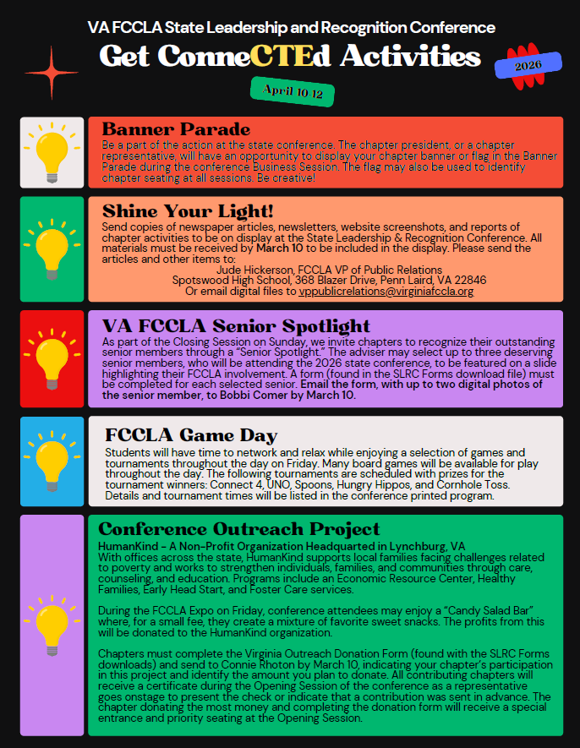
FOR ALL ADVISERS
Opportunities to Strengthen Your FCCLA Chapter

2026 State Leadership & Recognition Conference
Virginia Beach ~ April 10-12

Friday, April 10
- STAR Events ~ serve as an event room consultant or evaluator ~ a great opportunity to see curriculum integration and/or classroom application in all FCS instructional areas. Please note that all chapters entering students in competition are required to provide at least one volunteer.
- The FCCLA Expo with the opportunity to connect with college and university representatives with FCS-related degrees; also get ideas for chapter projects and fundraising activities.
- The Opening General Session will have leadership and character development in students as its theme. Project ideas and FCCLA classroom activities will be featured on screen. An energizing Think Fast interactive event will challenge students and adults to show their FCS related knowledge.

Saturday, April 11
- The Business Session demonstrates youth leadership and application of parliamentary procedure. The election of new state officers provides great examples of public speaking to promote FCCLA.
- Adviser Workshop – Advisers will participate in an exclusive session designed to facilitate networking and sharing of best practices for managing your chapter and making FCCLA a vital component of your FCS instruction.
- The Awards Banquet highlights accomplishments of Virginia chapter advisers and other adults whose efforts have strengthened our state association.

Sunday, April 12
- The Closing General Session will wrap up the conference, including the awarding of STAR Events medals, scholarships, and trophies, and the announcement of national competition qualifiers.
- The National Leadership Conference Information Session is a required session for all advisers interested in attending that conference – the national conference has several adviser sessions related to curriculum development and career pathways.

Address specific questions regarding professional development activities for FCS teachers during the FCCLA State Leadership & Recognition Conference to:

Kathleen Buchanan, Virginia Membership & Adviser Development Coordinator
4216 Maury River Road
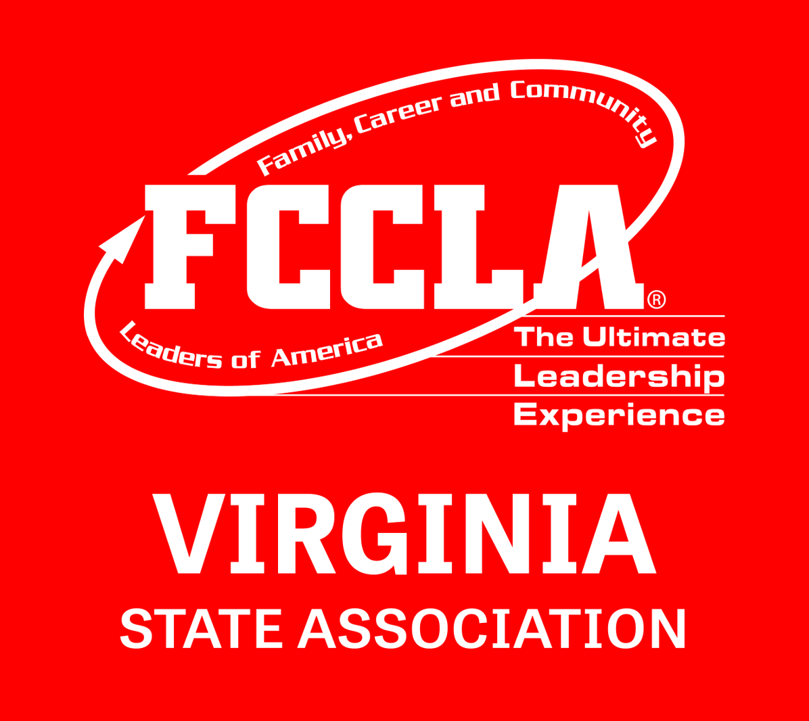
Rockbridge Baths, VA 24473

Phone: (540) 348-5377
Email: kvcbuchanan@gmail.com

