Virginia Beach Aquarium
Group Ticketing Information
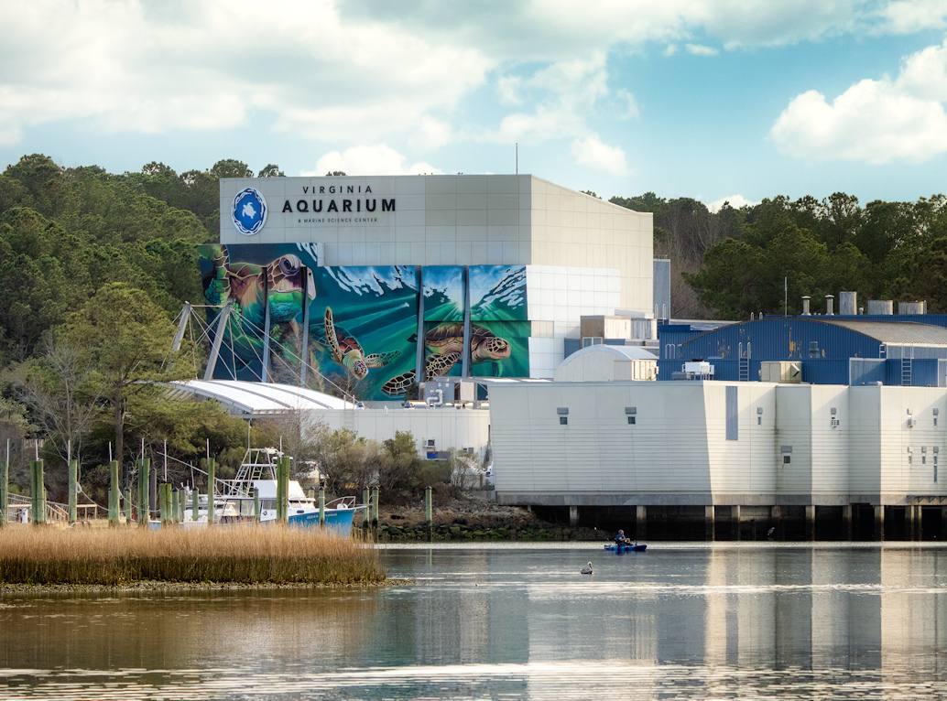
Virginia FCCLA chapters attending the State Leadership & Recognition Conference may purchase discounted youth group tickets and make reservations for admission date and time. Groups must be 15 or more attendees (including adults) so chapters with fewer may want to join with another chapter to purchase group tickets.

Please follow these instructions:
- Send an email to: vamscgso@virginiaaquarium.com
- Include the following information - must have 15 or more people in group:
  - School Name:
  - Adviser/Chaperone Name:
  - Adviser email:
  - Date and Time of Requested Admission:
  - Number of Students @ $15 each:
  - Number of Adults @ $25 each:
- Be sure to indicate you are attending the Virginia FCCLA conference at the Virginia Beach Convention Center (NOTE: VA FCCLA state staff spoke with the aquarium guest services to arrange this process.

The Aquarium hours of operation are 9:00 a.m. – 5:00 p.m. with a last admission time of 3:30 p.m.
