Special Event: FCCLA Night at the Washington Nationals

TUESDAY, JULY 7 6:00 – 9:00 PM
Get ready for a grand slam night with fellow FCCLA members! ⚾
Join us at Nationals Park as the Washington Nationals take on the Houston Astros for a 6:45 PM game. Wear your blue FCCLA t-shirt, bring the energy, and cheer on the D.C. home team while making unforgettable memories with friends from across the country.
Chapters will be seated together, and FCCLA has reserved blocks of seats throughout the stadium so we can all enjoy the game near one another. It’s sure to be a home run for the entire conference!
Please note: Transportation is not included. The stadium is just a quick Metro or Uber ride from the convention center area.
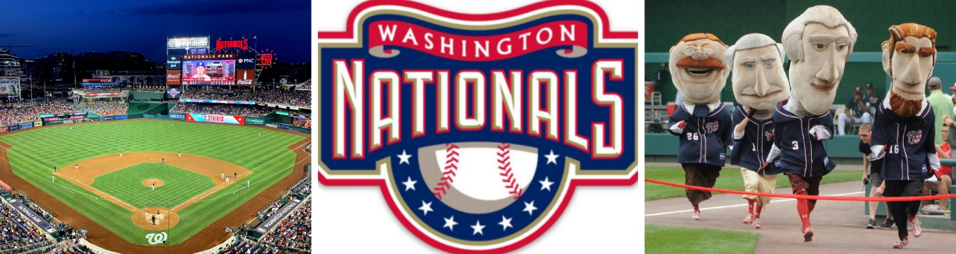

Cost: $60 per person
Price includes:
- Individual game ticket with an assigned seat (per person)
- Ticket includes a $20 voucher that can be used for (food or souvenirs per person)
- Navy blue FCCLA shirt for the event (per person)
Attire: Navy blue FCCLA t-shirt is encouraged. Wear your patriotic red, white, and blue to celebrate the nation’s 250th anniversary! (School Appropriate casual)

Please note: There is a limited capacity of 5,000 attendees so register early.

Rock the Red Rally on Capitol Hill

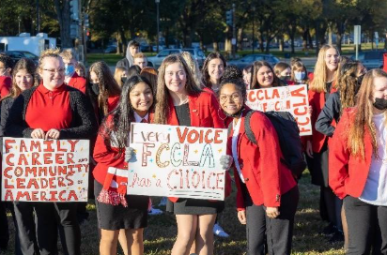THURSDAY, JULY 9 9:00 – 10:00 AM
In partnership with USEP-Ohio, the rally will connect student wellness to real world impact, reinforcing how leadership in health and safety creates stronger schools and safer communities. Attendees can expect music, movement, and a strong visual presence as FCCLA comes together in one unified space to represent the power of student leadership on a national stage.
The experience will conclude with an official attempt to break the world record for the largest group performing the Macarena at one time. Thousands of FCCLA Members and Advisers participating together on Capitol Hill will create a memorable moment that blends celebration with purpose. Participants will leave energized, proud, and part of a historic milestone for FCCLA.
Rock the Red Rally on Capitol Hill will be a standout moment of the conference and a visible reminder of the strength and impact of FCCLA nationwide.
Please note: Transportation is not included. This area is very walkable and accessible from the surrounding Metro stations (e.g., Capitol South, Union Station, Federal Center SW)
Location: Union Square, directly in front of the U.S. Capitol reflecting pool.
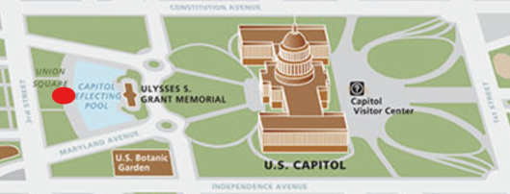

Cost: Free Attire: Red FCCLA Conference t-shirt or red attire preferred to have a unified red presence. (School Appropriate casual) Official Uniform should be worn if advocating on Capitol Hill afterwards.

