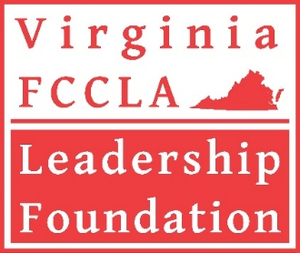

William W. McAnulty

FCCLA MINI-GRANTS
2026-2027 SCHOOL YEAR

The Virginia FCCLA Leadership Foundation is announcing a mini-grant opportunity to affiliated chapters throughout Virginia for implementation of one of the FCCLA national programs. This mini-grant is being offered in honor of Bill McAnulty, a founding board member.
- The maximum allowed under any one approved grant is $500, and some projects may be partially funded, depending on the number of applications and available funds.
- A school can only submit one application for one national program project.
- Only mini-grant applications received by email on or before the October 1 deadline date will be considered.
- Grant awards will be determined at the fall meeting of the foundation’s Board of Directors and will be announced soon thereafter. Funds will be disbursed to selected chapters upon return of a signed commitment form and evidence of chapter affiliation.

Examples of a special project that could be funded include (but are not limited to):
- Conduct promotional/educational campaigns promoting the focus of the national program that you have selected
- Sponsor youth-friendly community event(s) related to the focus of the selected national program
- Provide educational resources to such groups as health departments, early childhood education or senior centers, local elementary schools, local libraries, etc. related to the national program topic
- Partner with school and/or community organizations or businesses to provide a special project related to the national program
- Partner with your school’s PTA on an issue of shared interest
- Implement project idea(s) from the national FCCLA curriculum materials

How to Apply for the Bill McAnulty Mini-Grant

Complete the application on page five of this announcement. Answer all questions completely within each box. Completed applications may not exceed two pages and may not include links to additional information or items requested for purchase. Delete the front, generic pages and email only the completed application and blank rubric to Deborah Will, Foundation Coordinator at debbiewillFCCLA@comcast.net.

All applications received by email on or before the October 1 deadline will be considered for funding. Chapters will be notified following the fall meeting of the foundation Board of Directors regarding the status of their application. Approved chapters will be asked to sign a commitment form before payment is sent to the chapters; payment is sent following confirmation of chapter affiliation.

A final report will be made through completion and submission of the national program award application for your chosen project. All recipients of funding under this mini-grant will be required to submit the online National Program Award application (NOT the “Project Summary Only”) through the affiliation portal by the March 1 deadline, and chapters will also be asked to share some photos of your project. National Program Awards will also be presented at the State Leadership & Recognition Conference in the spring.

Pointers for Developing a Stronger
Mini-Grant Application

- Failure to follow guidelines for completion of the application may disqualify your request. This may happen if there are a large number of applications submitted as part of a narrowing-down process.
- For this school year, there will be a guaranteed mini-grant awarded for Financial Fitness thanks to a partnership with the Virginia Bankers Association. Special consideration will be given to a project focused on saving and protecting money (relating it to banking).
- Consider implementing a project centered around a current issue.
- The grant reviewers are particularly receptive to projects that have a longer-term impact, rather than a one-time event.
- Innovative, new ideas are preferred, rather than projects that have been done before.
- Descriptions of the activity/activities need to be very specific, not general. However, do not include links to other information or items to be purchased – all grant information should be contained within the pages of the application only.
- List only budget items that are essential to carrying out the project and do not go over the $500 maximum grant amount.
- If there are other sources of funding or donations, be sure to list those and put dollar values for each, even if estimated. Many of the strongest mini-grant applications show partnerships with other organizations.
- Before listing specific instructional materials and/or equipment in your budget, check with your CTE administrator first to see if these items can be purchased with Perkins funds. If so, they can be listed as an in-kind donation from your school system.

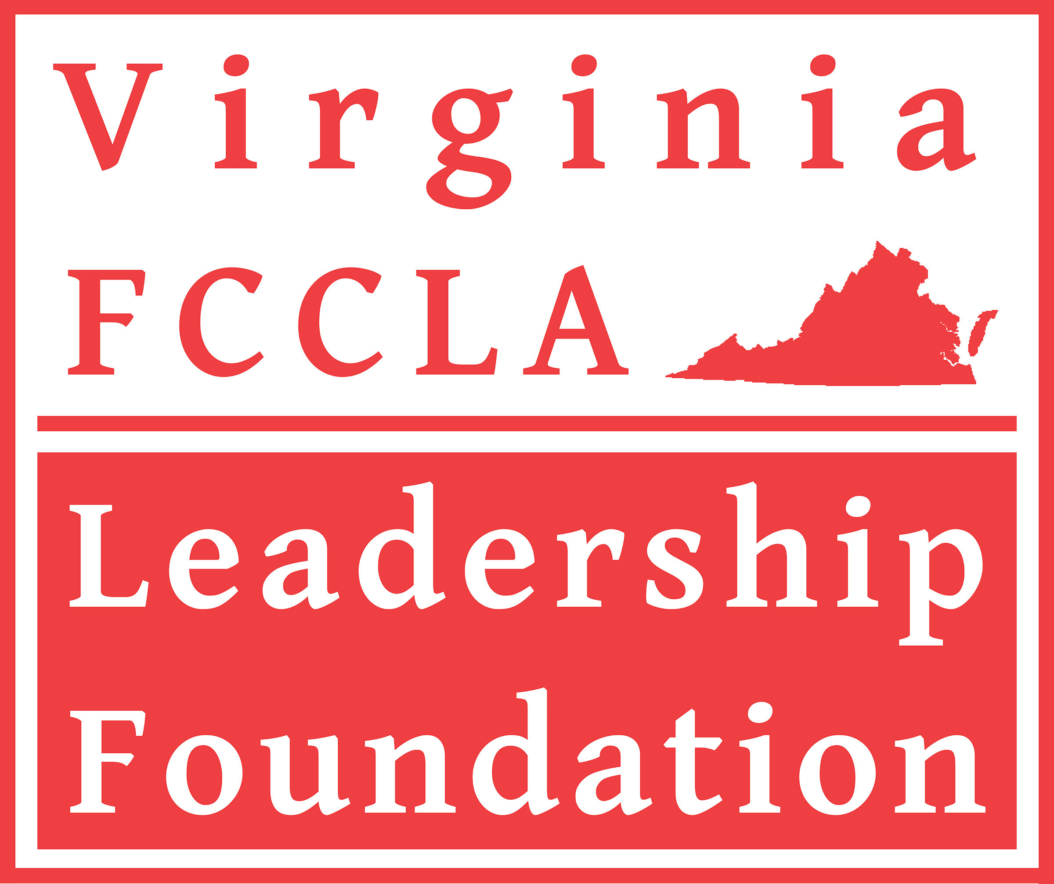
William W. McAnulty

MINI-GRANT PROGRAM FOR VIRGINIA FCCLA CHAPTERS

FCCLA
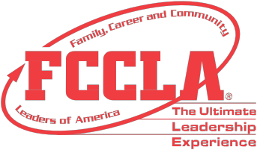

NATIONAL PROGRAMS

CAREER CONNECTION


Find your career pathway through My Skills, My Life, My Career, and My Path

COMMUNITY SERVICE


Learn, Lead, and Serve

FAMILIES ACTING FOR COMMUNITY TRAFFIC SAFETY (FACTS)
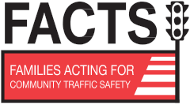

Save lives through Personal, Vehicle, and Road Safety

FAMILIES FIRST


Strengthen family relationships

FINANCIAL FITNESS


Earn, Spend, Save, and Protect money wisely

POWER OF ONE
Find and use your personal power in one or all of these units: A
Better You, Family Ties, Working on Working, Take the Lead,
and Speak Out for FCCLA


STAND UP
Assess current needs, educate others regarding concerns, and advocate to make a difference now and in the future

STUDENT BODY
Learn about the Healthy you, the Fit you, the Real you, and the Resilient you

Virginia FCCLA Areas

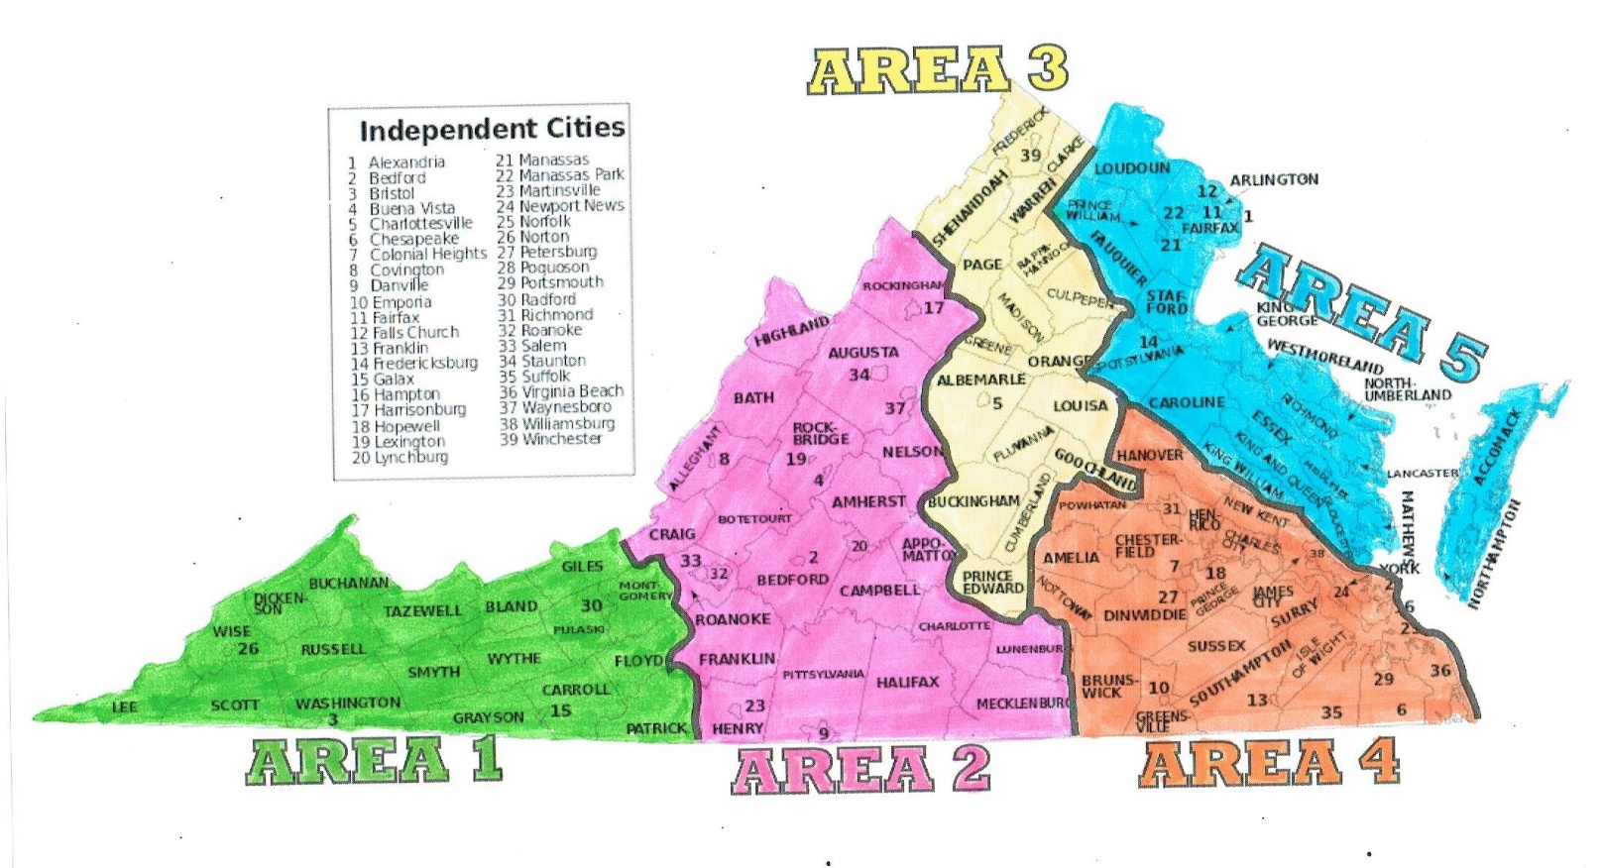
Virginia FCCLA Leadership Foundation
2026-2027 Mini-Grant Application

E-mail deadline: October 1 This form may be continued to a second page
Please delete the front, generic pages and submit just the application and rubric
Answer the following questions: | Enter your responses below:
- Name of School and  circle/highlight VA FCCLA Area | School:  Area 1 Area 2 Area 3 Area 4 Area 5
2. Complete Mailing Address
3. Name of FCCLA Adviser
4. Email Address of Adviser
5. School’s Federal ID Number
6. Counties/Cities to be Served by Project
7. Describe the activities planned for the mini-grant – please be as specific as possible. Be sure to include the following:
- What is the selected national program?
- What activities will take place?
- How will the activities aid in the promotion of the theme of the FCCLA national program?
- When will the project take place?
- What is the audience?
8. Describe the budget. Include each line item for which you are requesting funding. Be sure to clearly describe each expense and how it relates to the project. Add or remove additional lines as necessary.
DO NOT GO OVER the $500 maximum.
Budget item: Dollar amount: Rationale:
TOTAL
In-kind or financial support from other sources for the project: |  |  | Please list supporting organizations:
SAMPLE EVALUATION RUBRIC
VIRGINIA FCCLA LEADERSHIP FOUNDATION MINI-GRANTS
Chapter: FCCLA Area:
MINI-GRANT PROPOSAL (Possible Points: 0 to 25) Points
Project Description  The project description includes the name of the selected national FCCLA program and a thorough description of the project goals and activities.  0-5 points | 0  No Evidence  There is no demonstrated evidence for the criteria being addressed. | 1  Basic  There is little demonstrated evidence for the criteria being addressed. | 2-3  Promising  There is ample demonstrated evidence for the criteria being addressed. | 4-5  Exemplary  There is significant demonstrated evidence for the criteria being addressed.
Project Implementation  The timeline for implementing the project is realistic.  0-5 points | 0 | 1 | 2-3 | 4-5
Budget  The budget includes a comprehensive list of expenditures and also identifies other sources of funding to support the project.  0-5 points | 0 | 1 | 2-3 | 4-5
FCCLA National Program  The project supports the goals of family and consumer science education through an identified FCCLA National Program.  The FACS body of knowledge is used to provide solutions to current issues facing individuals, families, or communities.  0-5 points | 0 | 1 | 2-3 | 4-5
Creativity and ability to be replicated in other schools.  The project is innovative and includes creative planning and implementation.  The project could be replicated in other FACS/FCCLA programs.  0-5 points | 0 | 1 | 2-3 | 4-5

TOTAL

Name of evaluator:

Ranking: recommend this request as out of total applications

